HUAWEI nova 15 Max Delivers 23 Hours of Nonstop Power

Alriyadh, 10 June 2026: The HUAWEI nova 15 Max is set to redefine smartphone endurance with its massive battery and durable design. Designed for users who demand reliable all-day performance without compromise, the latest addition to the nova series combines power, style, and innovation in one sleek device. Starting at 1299 SAR, the HUAWEI nova 15 Max is now available in the Kingdom of Saudi Arabia. Customers can reserve theirs through Huawei’s official online store.

The HUAWEI nova 15 Max is powered by an 8500mAh HUAWEI Super Battery, offering a larger battery capacity and longer battery life compared to the previous generation. Real-world testing shows the device can support up to 23 hours of continuous video playback, ensuring dependable performance throughout the day. The phone also introduces reverse charging technology, allowing users to conveniently power compatible Huawei devices on the go, effectively turning the smartphone into a portable power bank.

Built for durability, the HUAWEI nova 15 Max has achieved the SGS Premium Performance Mark 5-Star Drop Resistance certification, helping disperse impact force and reduce the risk of damage from everyday drops. In addition, precision sealing technology at key body joints helps block sand and dust, while the device’s IP65 rating provides reliable water and dust resistance for daily use.

For photography enthusiasts, the HUAWEI nova 15 Max comes equipped with a 50MP Ultra Vision Camera featuring an RYYB colour filter array that improves light intake by 40%. Combined with a large sensor and F1.9 aperture, the camera captures bright, detailed photos even in low-light environments without the need for additional lighting.

The experience is further enhanced by a stunning 6.84-inch OLED Eye Comfort Display that delivers immersive visuals with smooth responsiveness and intelligent viewing adaptation. Whether navigating outdoors under bright sunlight or binge-watching content late at night, users can enjoy a consistently comfortable and vivid viewing experience. With up to 4000 nits of dynamic peak brightness, the display ensures bright highlights, deep contrast, and rich detail in every scene.

All Apps are there
AppGallery is a well-developed app ecosystem with millions of apps available for download, and all world range top apps can be found on AppGallery. If some apps cannot be found on AppGallery, they can also be downloaded from Google Play on Gbox. After a long period of using Huawei mobile and now with the new HUAWEI nova 15 Max, almost all apps that you need to use in your life can be downloaded and used properly.

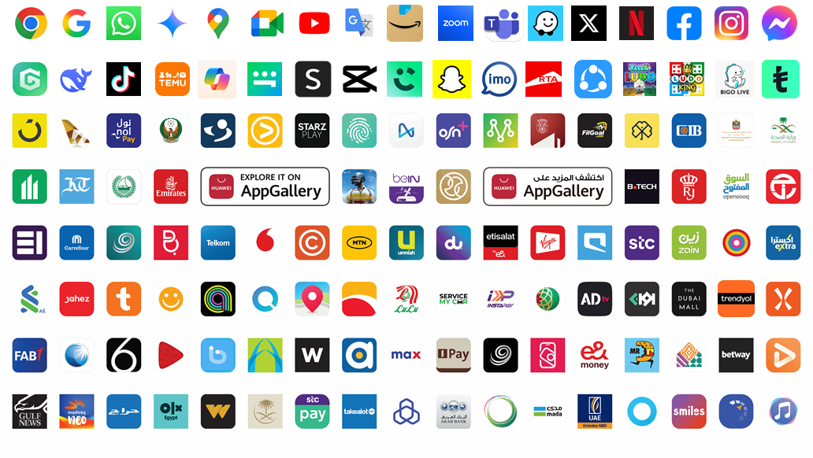
-Ends-

About HUAWEI Consumer Business Group (CBG)
Huawei Consumer Business Group (CBG) is one of Huawei’s three business groups, providing a range of products including smartphones, tablets, laptops, wearables, audio, monitors, smart screens, IOT and others.
In Jan 2023, Brand Finance reveals Global 500 2022 list of the world’s most valuable brands, Huawei ranks No. 31, Huawei’s brand value is US$44.3 billion.
In 2023, our total R&D spending reached more than USD 23 billion, representing 23.4% of Huawei’s total revenue. The total R&D investment over the last decade now exceeds USD 154 billion.
For more information, please visit: consumer.huawei.com/sa
For regular updates on HUAWEI Consumer BG, follow us on:
Facebook: facebook.com/HuaweiMobileKSA
Twitter: twitter.com/HuaweiMobileKSA
YouTube: youtube.com/Huaweimobileksa
Instagram: instagram.com/HuaweiMobileKSA

